**Tutorial B**

**Developing Ethereum Smart Contracts for Beginners**

This tutorial is very good to start with because it introduces about Bitcoin, Blockchain and Smart Contract in detail, which help me have a nice overview about these new technologies without misunderstand between Bitcoin and Blockchain. By following this tutorial, I was able to create and deploy a simple smart contract. However, it’s not enough technical for me to start create and deploy my smart contract for this project. I am also interested in Đapp, which use Blockchain as a Database (check out pictures below):

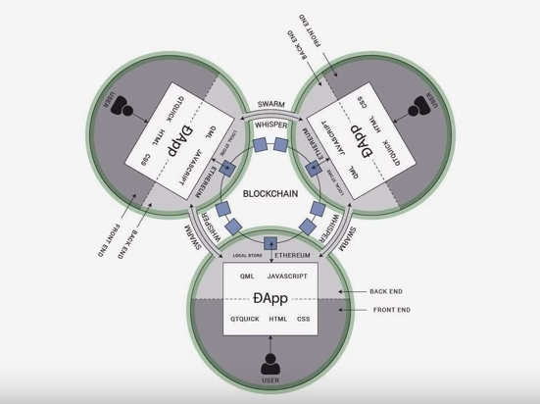

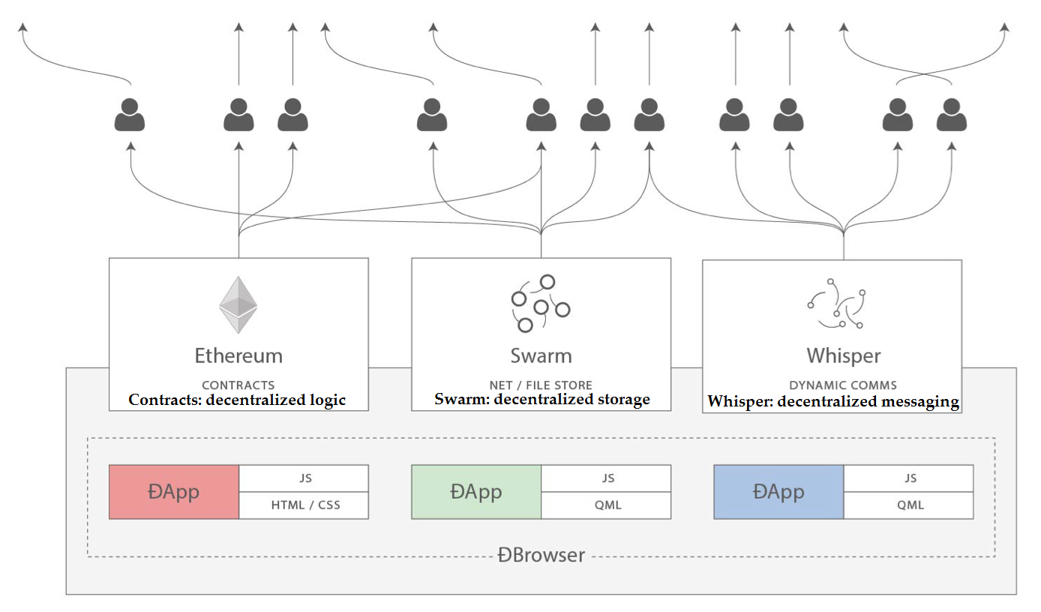

There is a problem I have to face with while following this tutorial at Bosch is Network. Bosch has so many employees and their network policy has some constraint which lead to slow or refuse connect to some site for me to download necessary packages and libraries. I think I will implement in my laptop at home then upload it on GitHub, then download and try to make it work correctly at Bosch under their network.

<https://coursetro.com/courses/20/Developing-Ethereum-Smart-Contracts-for-Beginners>